CPE301 – SPRING 2019

Design Assignment 5

Student Name: Alex Cater

Student #: 2000583031

Student Email: cater@unlv.nevada.edu

Submit the following for all Labs:

1. In the document, for each task submit the modified or included code (only) with highlights and justifications of the modifications. Also, include the comments.
2. Use the previously create a Github repository with a random name (no CPE/301, Lastname, Firstname). Place all labs under the root folder ESD301/DA, sub-folder named LABXX, with one document and one video link file for each lab, place modified asm/c files named as LabXX-TYY.asm/c.
3. If multiple asm/c files or other libraries are used, create a folder LabXX-TYY and place these files inside the folder.
4. The folder should have a) Word document (see template), b) source code file(s) and other include files, c) text file with youtube video links (see template).

1. **COMPONENTS LIST AND FLOW DIAGRAMS**

Atmega328PB Xplained Mini

Micro USB Cable (Power Supply)

Breadboard

LM35

RF24L01

Male/Female Wires

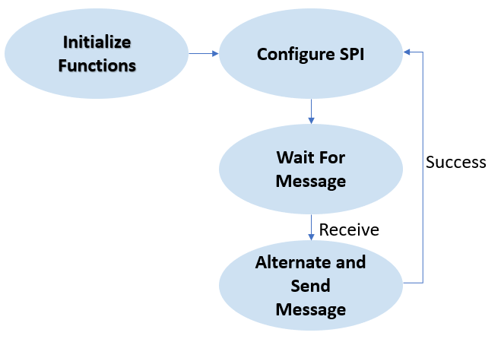

*Figure 1 – Flow Chart for Coding Algorithm in Task*

1. **INITIAL/DEVELOPED CODE OF TASK**

|  |
| --- |
| /* |
|  | * DA5.c |
|  | * |
|  | * Created: 5/7/2019 7:16:05 AM |
|  | * Author : acate |
|  | */ |
|  |  |
|  | #ifndef F_CPU |
|  | #define F_CPU 16000000UL |
|  | #endif |
|  |  |
|  | #include <avr/io.h> |
|  | #include <util/delay.h> |
|  | #include <avr/interrupt.h> |
|  | #include <stdbool.h> |
|  | #include <stdio.h> |
|  | #include <string.h> |
|  |  |
|  | // Set up UART for printf(); |
|  | #ifndef BAUD |
|  | #define BAUD 9600 |
|  | #endif |
|  | #include "STDIO_UART.h" |
|  |  |
|  | // Include nRF24L01+ library |
|  | #include "nrf24l01.h" |
|  | #include "nrf24l01-mnemonics.h" |
|  | #include "spi.h" |
|  | void print_config(void); |
|  |  |
|  | void adc_init(void); // Function to initialize Analog to Digital Converter |
|  | void read_adc(void); // Function to read temperature received from ADC |
|  | void USART_send(unsigned char data); // Function to send individual char data into UDR0 |
|  | void USART_putstring(char* StringPtr); // Function to break string into individual chars and send |
|  |  |
|  | volatile float adc_temp; // Stores ADC Value representing Temperature |
|  | char outs[20]; // 'outs[]' used to store integer and float values into array of chars size 20 |
|  |  |
|  | // Used in IRQ ISR |
|  | volatile bool message_received = false; |
|  | volatile bool status = false; |
|  |  |
|  | int main(void) { |
|  |  |
|  | // Set cliche message to send (message cannot exceed 32 characters) |
|  | char tx_message[32]; // Define string array |
|  | strcpy(tx_message,"Hello World!"); // Copy string into array |
|  |  |
|  | // Initialize UART |
|  | uart_init(); |
|  | adc_init(); |
|  | float adc_tempf; |
|  |  |
|  | // Initialize nRF24L01+ and print configuration info |
|  | nrf24_init(); |
|  | print_config(); |
|  |  |
|  | // Start listening to incoming messages |
|  | nrf24_start_listening(); |
|  | status = nrf24_send_message(tx_message); |
|  | if (status == true) { |
|  | printf("Message sent successfully\n") |
|  | read_adc(); |
|  | adc_tempf = (ADCH << 8) + ADCL; // Let 'T(C) = Vout/10mV' and 'TOS = ADC - T(C)' |
|  | adc_tempf = (9/5)*adc_tempf + 32; // Converts Celsius to Fahrenheit |
|  | snprintf(outs,sizeof(outs),"%3f\r\n", adc_tempf);// Stores integer 'adc_temp' into the string 'outs' |
|  | USART_putstring(outs); |
|  | } |
|  |  |
|  | while (1) { |
|  |  |
|  | status = nrf24_send_message(tx_message); |
|  |  |
|  | if (message_received) { |
|  |  |
|  | // Message received, print it |
|  | message_received = false; |
|  | printf("Received message from geo: %s\n",nrf24_read_message()); |
|  | // Send message as response |
|  | _delay_ms(500); |
|  | if (status == true) printf("Message sent successfully\n"); |
|  | } |
|  | } |
|  | } |
|  |  |
|  | // Interrupt on IRQ pin |
|  | ISR(INT0_vect) { |
|  | message_received = true; |
|  | } |
|  |  |
|  | void print_config(void) { |
|  | uint8_t data; |
|  | printf("Startup successful\n\n nRF24L01+ configured as:\n"); |
|  | printf("-------------------------------------------\n"); |
|  | nrf24_read(CONFIG,&data,1); |
|  | printf("CONFIG 0x%x\n",data); |
|  | nrf24_read(EN_AA,&data,1); |
|  | printf("EN_AA 0x%x\n",data); |
|  | nrf24_read(EN_RXADDR,&data,1); |
|  | printf("EN_RXADDR 0x%x\n",data); |
|  | nrf24_read(SETUP_RETR,&data,1); |
|  | printf("SETUP_RETR 0x%x\n",data); |
|  | nrf24_read(RF_CH,&data,1); |
|  | printf("RF_CH 0x%x\n",data); |
|  | nrf24_read(RF_SETUP,&data,1); |
|  | printf("RF_SETUP 0x%x\n",data); |
|  | nrf24_read(STATUS,&data,1); |
|  | printf("STATUS 0x%x\n",data); |
|  | nrf24_read(FEATURE,&data,1); |
|  | printf("FEATURE 0x%x\n",data); |
|  | printf("-------------------------------------------\n\n"); |
|  | } |
|  |  |
|  | void adc_init(void) { |
|  | ADMUX = (0<<REFS1)|(1<<REFS0)| // Reference Selection Bits, AVcc - External cap at AREF |
|  | (0<<ADLAR)| // ADC Left Adjust Result |
|  | (0<<MUX3)|(1<<MUX2)|(0<<MUX1)|(1<<MUX0); |
|  |  |
|  | ADCSRA = (1<<ADEN)| // ADC Enable |
|  | (0<<ADSC)| // ADC Start Conversion |
|  | (0<<ADATE)| // ADC Auto Trigger Enable |
|  | (0<<ADIF)| // ADC Interrupt Flag |
|  | (0<<ADIE)| // ADC Interrupt Enable |
|  | (1<<ADPS2)|(0<<ADPS1)|(1<<ADPS0); |
|  | } |
|  |  |
|  | void read_adc(void) { |
|  | unsigned char i = 4; // Set 'i' for iterations |
|  | adc_temp = 0; // set float 'adc_temp' |
|  | while (i--) { // Decrement 'i' until 4 samples take |
|  | ADCSRA |= (1<<ADSC); // If ADSC is high (ADC Start Conversion)... |
|  | while (ADCSRA & (1<<ADSC)); // Start the ADC Conversion |
|  | adc_temp += ADC; // Store the analog value on of current adc_temp |
|  | _delay_ms(50); |
|  | } |
|  | adc_temp = (adc_temp/4); // Average of 4 samples taken into adc_temp |
|  | } |
|  |  |
|  | void USART_send(unsigned char data) { // Function to transmit ASCII value into UDR0 |
|  | while (!(UCSR0A & (1 << UDRE0))); // Keep Checking until UDRE0 data register 'High' to break loop |
|  | UDR0 = data; // Store unsigned char serial data into UDR0 |
|  | } |
|  |  |
|  | void USART_putstring(char* StringPtr) { // Function to break string into chars, then USART_send() |
|  | while (*StringPtr != 0x00) { // Keep Looping until String Completed (null/0-bits) |
|  | USART_send(*StringPtr); // Send the unsigned char value pointed by the string pointer |
|  | StringPtr++; // Increment pointer to next char array location |
|  | } |
|  | } |

1. **SCHEMATICS**

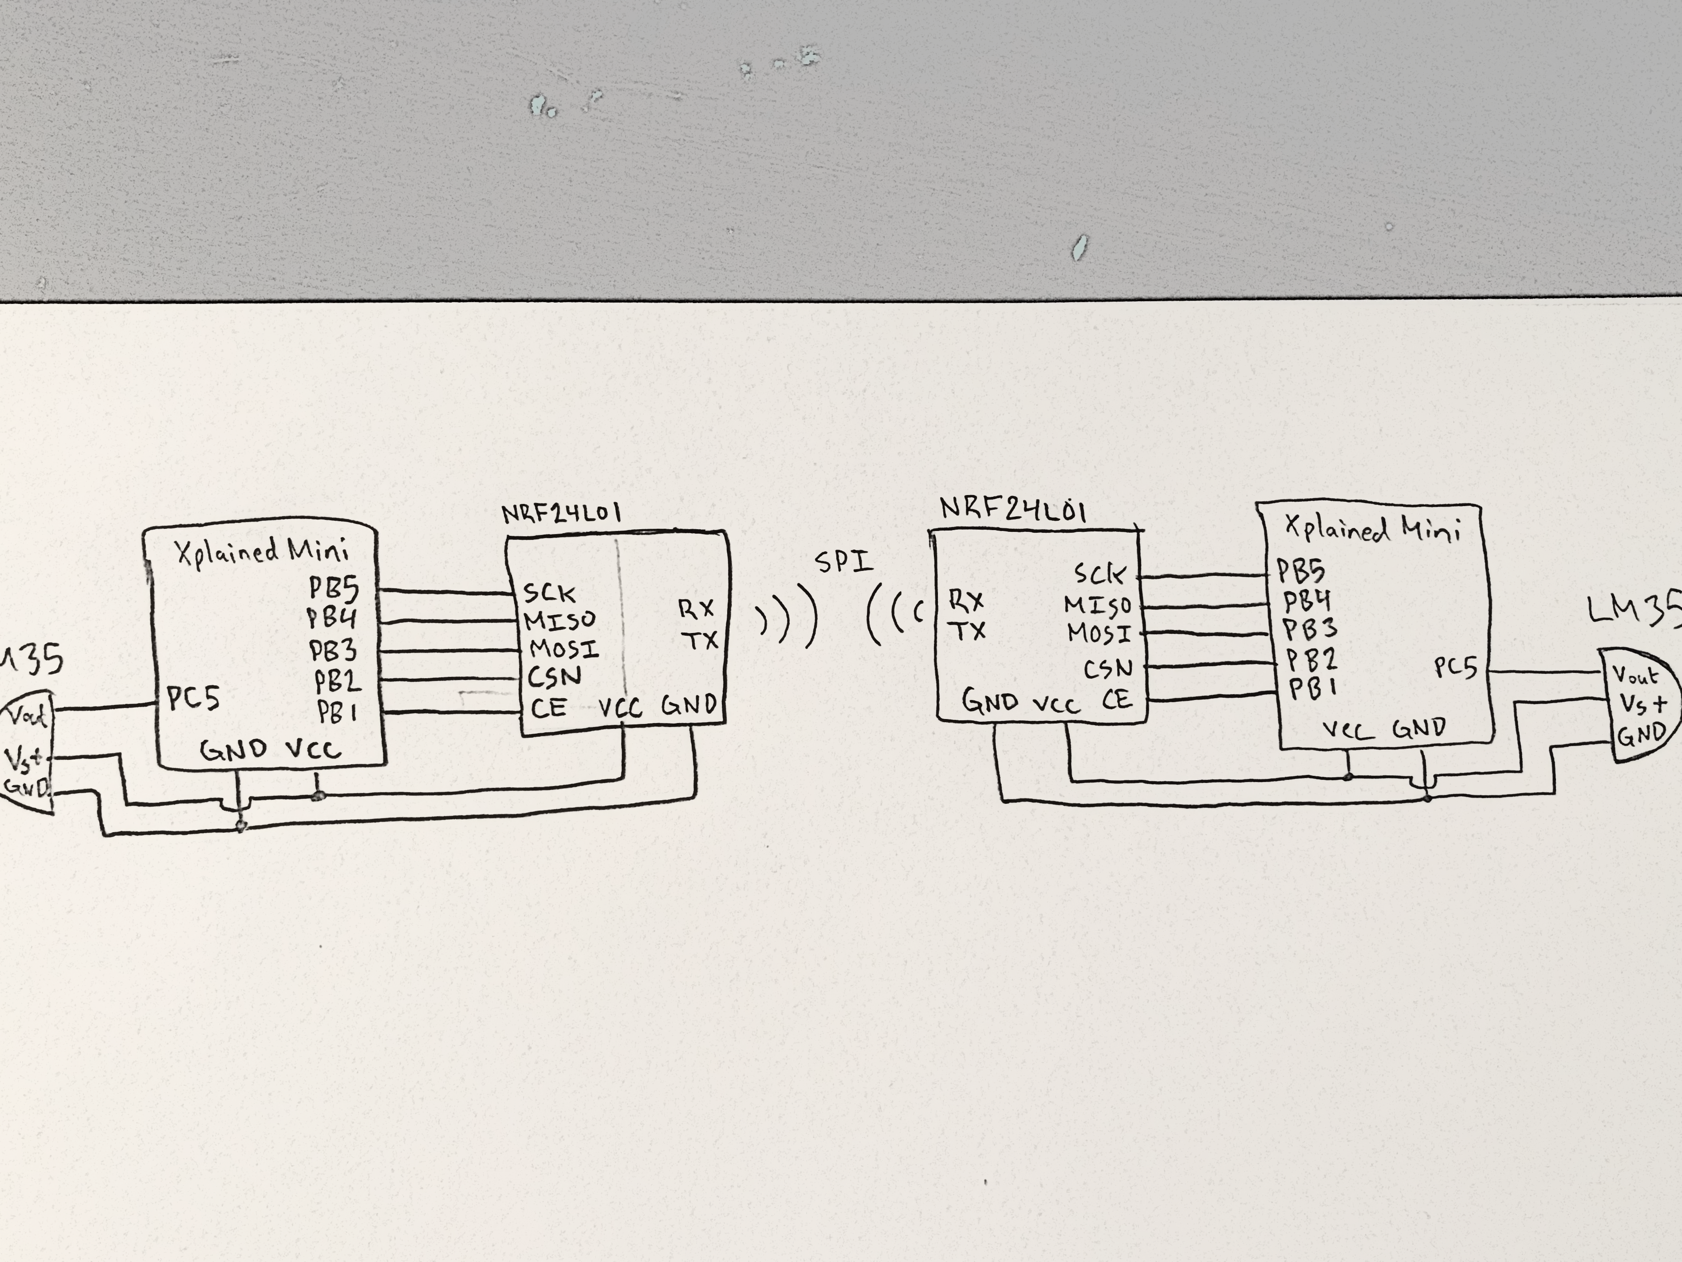

*Figure 2 – Schematic of two Atmega328P/PB Xplained Minis + SPI Modules*

1. **SCREENSHOTS OF EACH TASK OUTPUT (ATMEL STUDIO OUTPUT)**

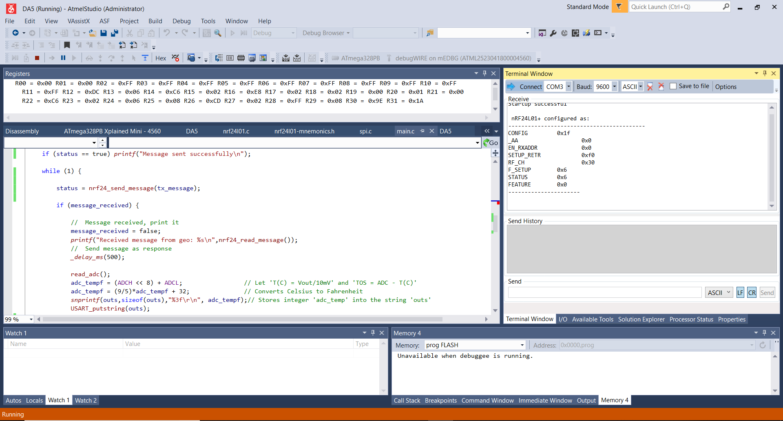

*Figure 3 – Output Terminal for Configuration of SPI Module*

1. **SCREENSHOT OF EACH DEMO (BOARD SETUP)**

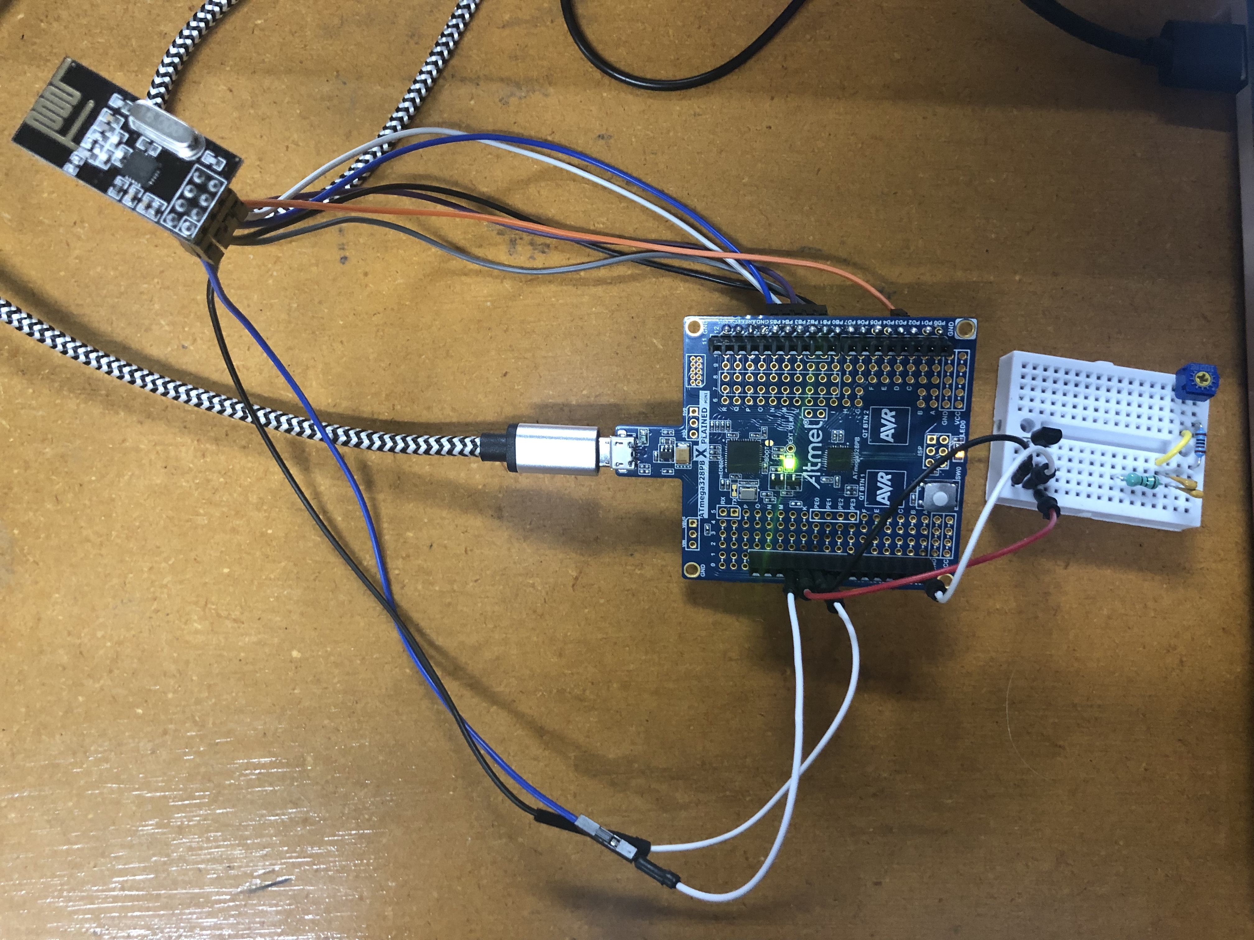

*Figure 4 – Connecting NRF24L01 to the Xplained Mini + LM35 Temperature Sensor*

1. **VIDEO LINKS OF EACH DEMO**

N/A

1. **GITHUB LINK OF THIS DA**

https://github.com/katmando/asdfghjkl/tree/master/DesignAssignments/DA5

**Student Academic Misconduct Policy**

<http://studentconduct.unlv.edu/misconduct/policy.html>

“This assignment submission is my own, original work”.

Alex Cater